## Chapter 4 Methodology

# Proposed Solution

The proposed system focuses on size efficiency of the output video. System acts well in the environment where there is storage issue and bandwidth issue in terms of internet transfer rate. Ultra-durability makes the system more portable to use and more reliable to handle. Repositionable cameras make the system able to work well in different canvas sizes i.e. size of writing board. System automates the process of video compression technique. Video of the lecture is not recorded as it as video format rather only the important data is extracted. By utilizing the stereo vision and high-speed cameras and low wireless latency, video animation and sound quality is maintained in noisy environment as well.

### General Proposed Model

General working model of the system can be seen as below

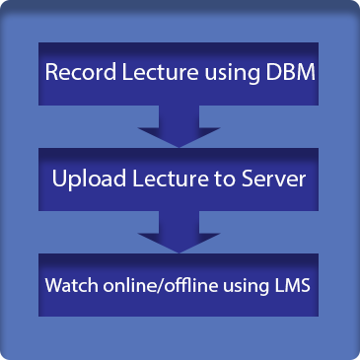

Figure 4.1: General Methodology View of the System

### General Flow

The system consists on several modules and deliverables one of which is controller application. This application is quite important because it include major functionalities and complex image processing algorithms. Furthermore, the instructor in mainly connected to the controller application so that he/she is controlling the recording of lecture i.e. he can start, pause or stop the recording. After the lecture is recorded, he can replay the lecture for any further changes. When the lecture is finally uploaded to central computer, students can play lecture online or save the lecture file in .dbm[1] extension to watch later. Offline player is also one of the major modules of the project. It plays the downloaded lecture file just like video player. Learning management system is the online platform where all uploaded online lecture hierarchy is accessible. It is a comprehensive management system designed by placing the convenience of instructor and student in focus. Reliability, security and quality are the top priorities.

A simple visual of the working of system can be seen as below

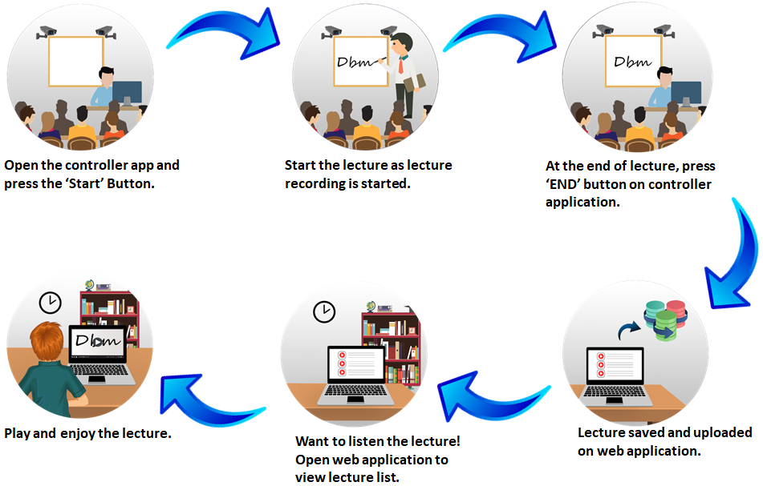

Figure 4.2: General Flow of the Project

### Board Marker

Board marker transfer the position data of currently written word on the platform i.e. Whiteboard. It is subdivided in two sub-modules

#### Stereo Vision Cameras

At least two high framerate cameras get the video of back ball and send it to controller application. Stereo vision is important for accurately extracting marker position by placing these cameras at such position so that different angles make same alignment to the writing platform irrespective to size. Square and rectangular boards can be mapped to same parent algorithm with simple to calibrate camera placement guide.

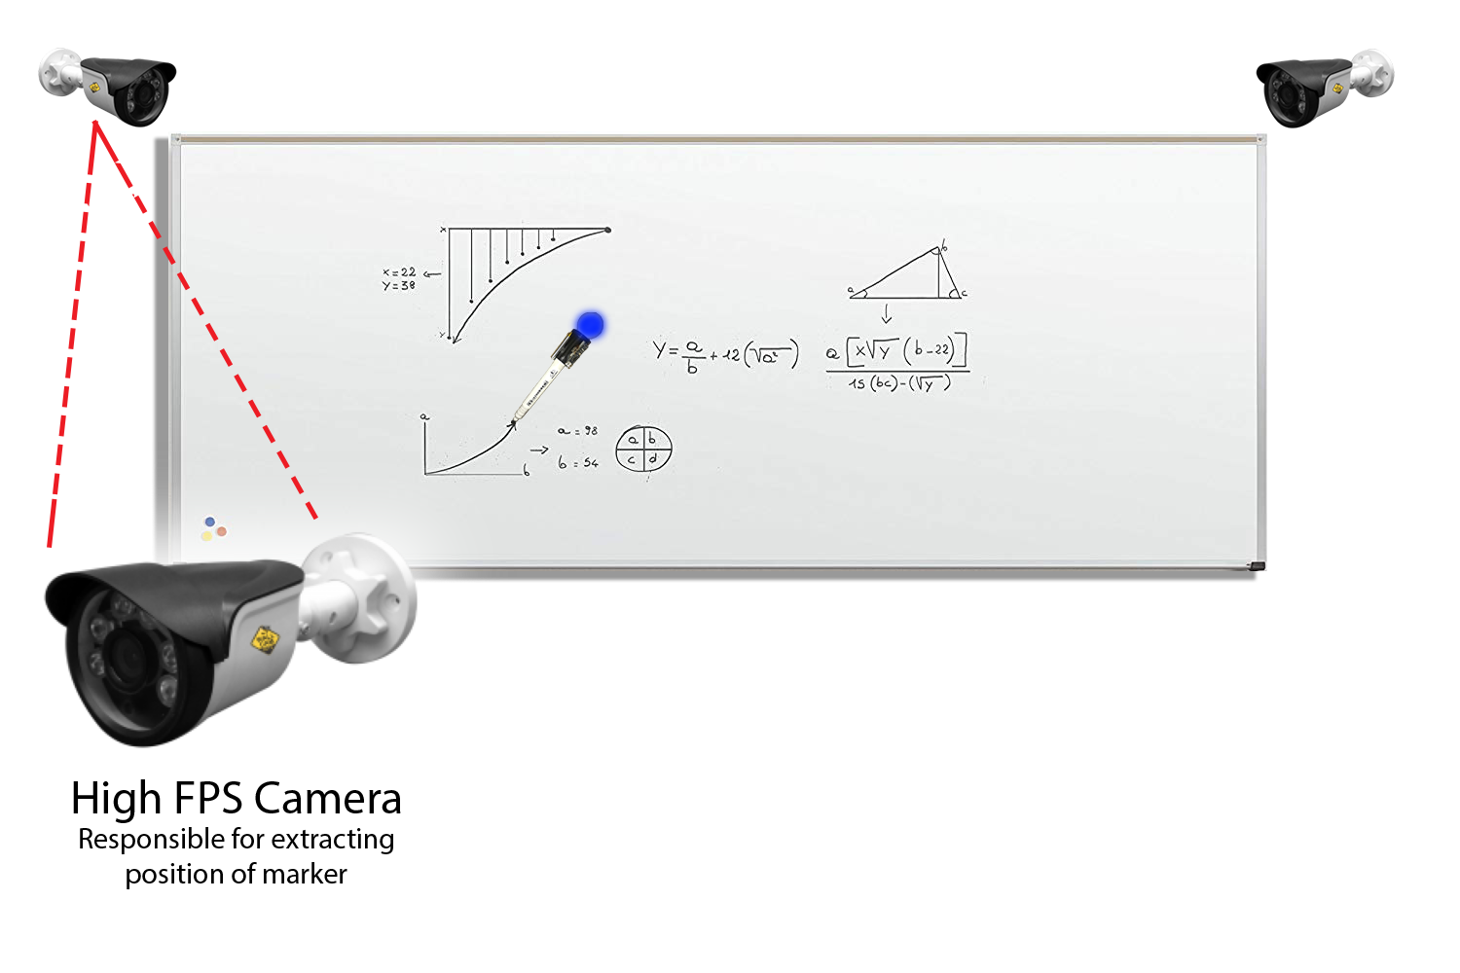

Figure 4.3: High framerate camera placement

#### Marker Hardware

To extract marker orientation, Marker Hardware is connected to controller application.

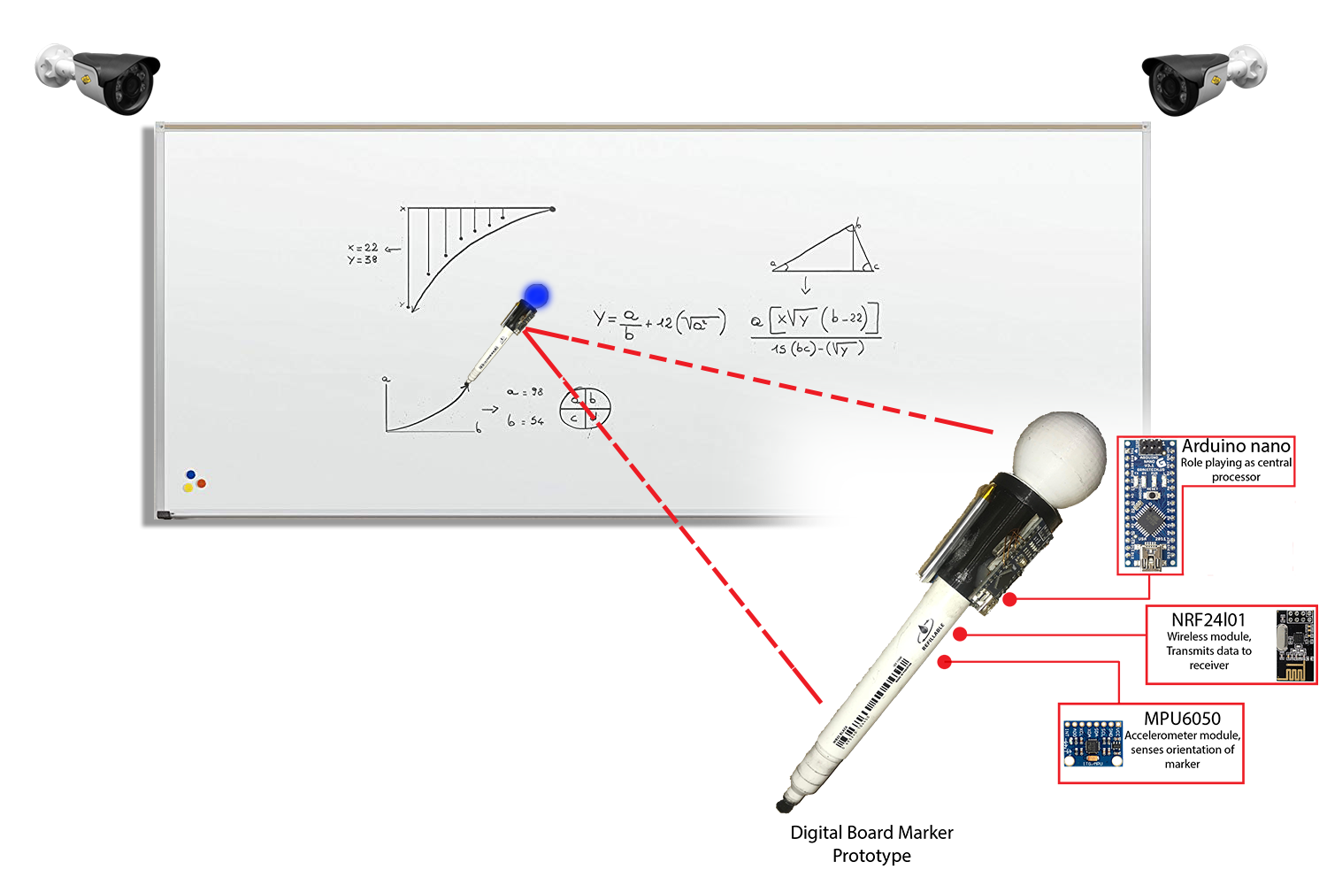

Figure 4.4: Marker Hardware working methodology

### Audio Hardware

Wireless voice transmission is done by this module. Voice data is accepted at transmitter module. This data is converted into digital audio. Digital audio is then transmitted to receiver at another end. Receiver module decode the digital audio into analog audio. Receiver module is attached to computer through Line-in[2] on which controller application is being executed. Controller application encode the analog audio into lightweight ogg[3] file format. After the audio file generation is successful, audio file is then embedded into lecture file and uploaded to central Server.

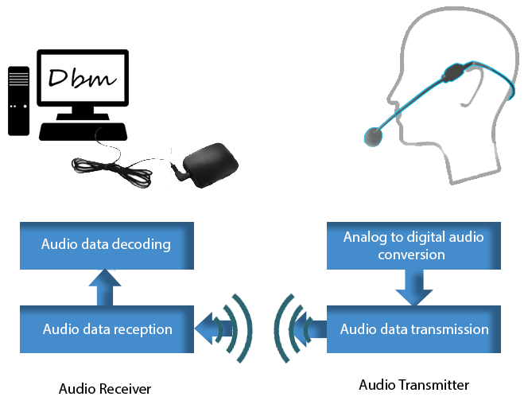

Figure 4.4: Audio Hardware General Methodology

### Controller Application